1. Use Case Diagram
The Use Case Diagram represents a platform designed to connect Victims, who post and manage aid requests, with Donors, who view and accept these requests. An Admin oversees the overall system, managing users and monitoring reports. The system incorporates mandatory OTP verification to ensure secure posting of requests, while integrated mapping services through OpenStreetMap provide accurate, location-based assistance. This structure highlights the primary interactions between users and the system, emphasizing both security and geographic awareness in the disaster relief process.

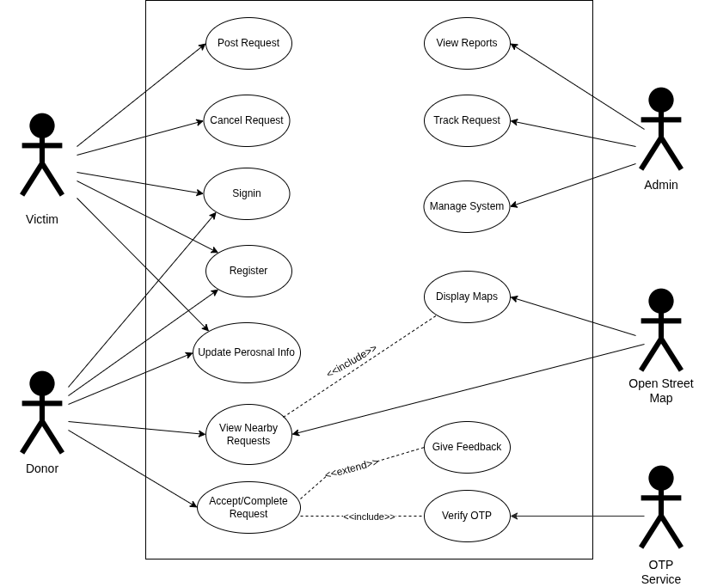
2. Deployment Diagram
The deployment diagram illustrates the physical architecture of the MERN based Disaster Relief Application, including the user device, frontend server, backend server, and database server. Users access the application through HTTPS. The React frontend is hosted on a cloud platform and communicates with the Node.js and Express backend via REST APIs. The backend connects to MongoDB Atlas to store and retrieve disaster relief requests and user data.

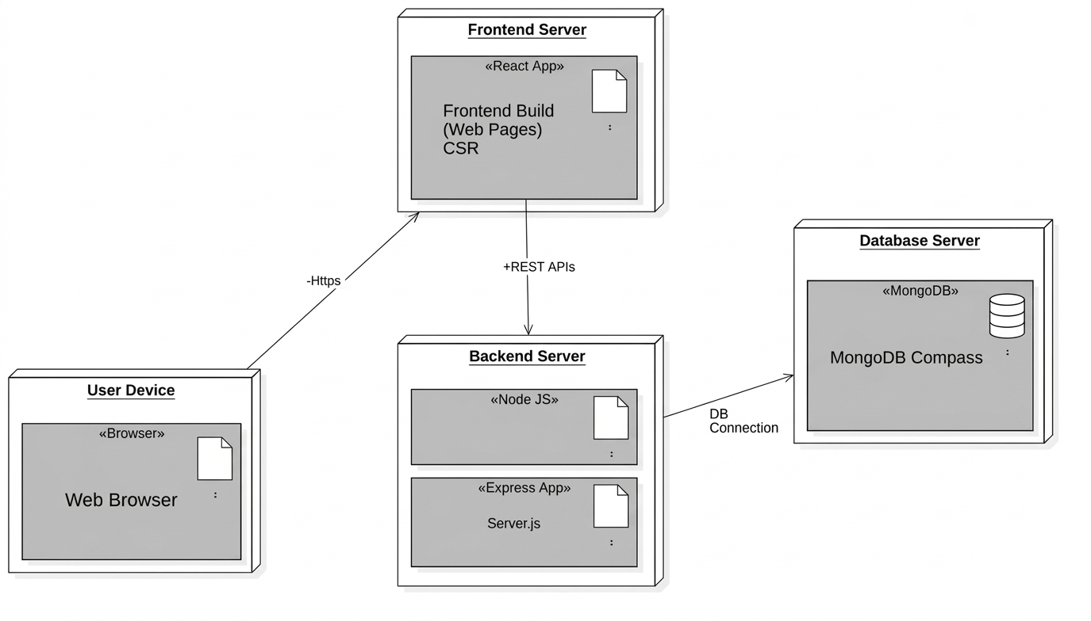

3. Class Diagram
The class diagram presents a User hierarchy in which Victims, Donors, and Admins inherit common authentication and profile attributes while performing their specific roles within the system. The core of the system is the Request entity, which manages task details, status, and location, and maintains relationships with users for handling requests and feedback. System security and request completion are ensured through the Acceptance Verification component, which uses OTP generation and verification to validate transactions.

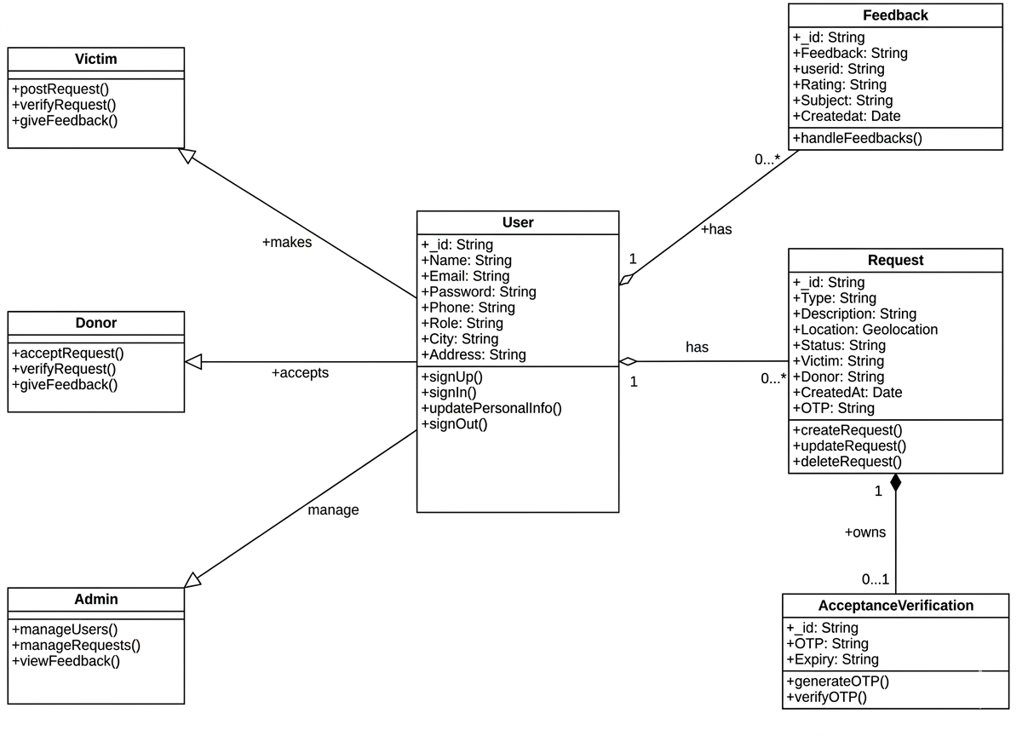

4. Sequence Diagram
This diagram shows how the victim, donor, frontend, backend, and database interact in the Disaster Relief Application. Victims post help requests which are stored and shown to donors on the map. Donors can accept requests, and the system updates the request status. Users can also give feedback.
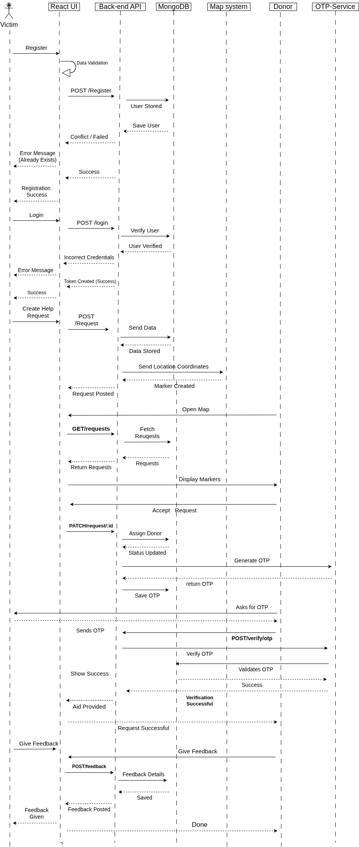

5. Entity – Relationship Diagram
The Entity–Relationship (ER) diagram illustrates the database structure of the Disaster Relief Application by showing the main entities, their attributes, and relationships. The system includes a User entity with roles such as Donor, Victim, and Admin, and a Requests entity that stores disaster relief requests. Victims can create multiple requests, while donors can accept and fulfill them. Each request contains attributes such as location, status, description, and timestamps, and is linked to both the victim who created it and the donor who accepted it.

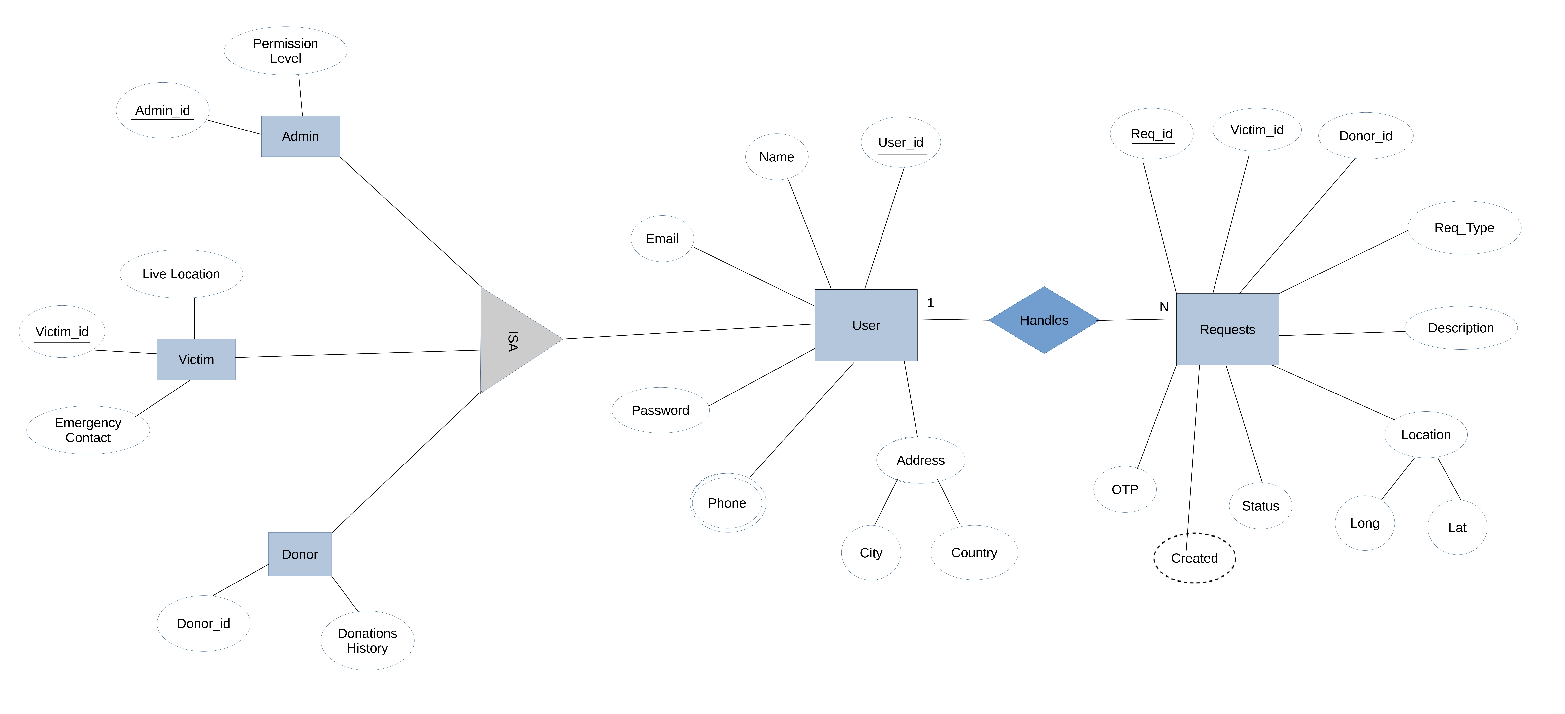

6. Data Flow Diagram
The system manages interactions between Victims, Donors, and Admins via a User class hierarchy. It uses RAG Query Processing and an LLM to provide AI-assisted responses from a knowledge base. Requests are tracked through creation, location mapping, and status updates, secured with OTP authentication. The backend maintains Users and Requests databases and includes a feedback loop for ratings and reviews.

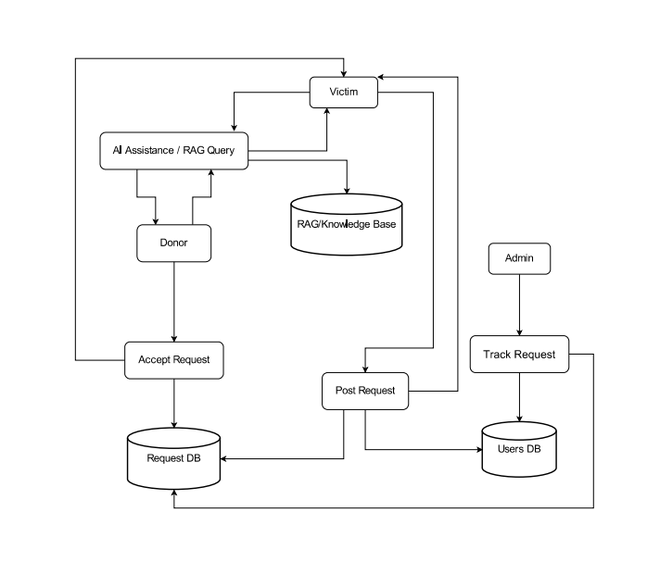

7. Component Diagram

This component diagram shows a MERN-based Disaster Relief System with modular architecture for user management, relief requests, and feedback. It integrates an AI subsystem (RAG Query Processor + LLM) for intelligent responses and external services for OTP verification and geographic awareness via OpenStreetMap.

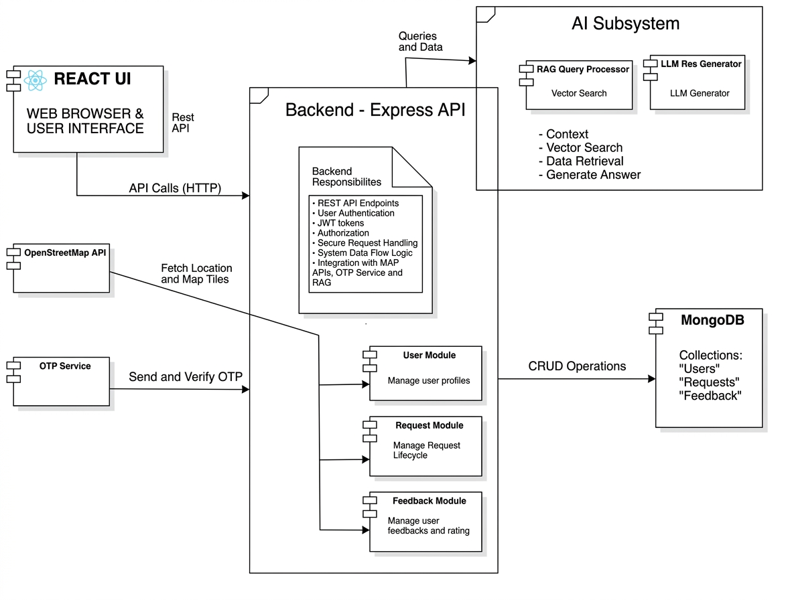

8. Activity Diagram
The activity diagram illustrates the workflow of the Disaster Relief Application, showing the sequence of actions from creating, submitting, and processing requests to completion. It highlights user and system interactions, decisions, and the flow of control, making it easier to understand how tasks are executed step by step.

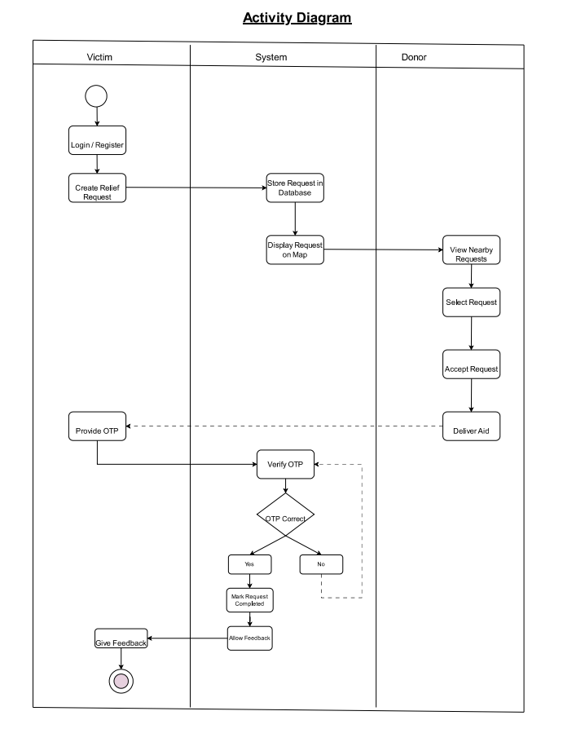

9. State Machine Diagram
The state diagram illustrates the different states of a request in the Disaster Relief Application and the transitions between them. The process begins at the Start state and progresses through Request Created, Request Submitted, and Processing, before reaching the final Completed state. Each state is represented by a rounded rectangle, while arrows indicate the transitions between states. This diagram provides a clear representation of the request lifecycle within the system without specifying events or actions.
